Final project - Technical report

Part 1 – introduction:

Part 2 system architecture:

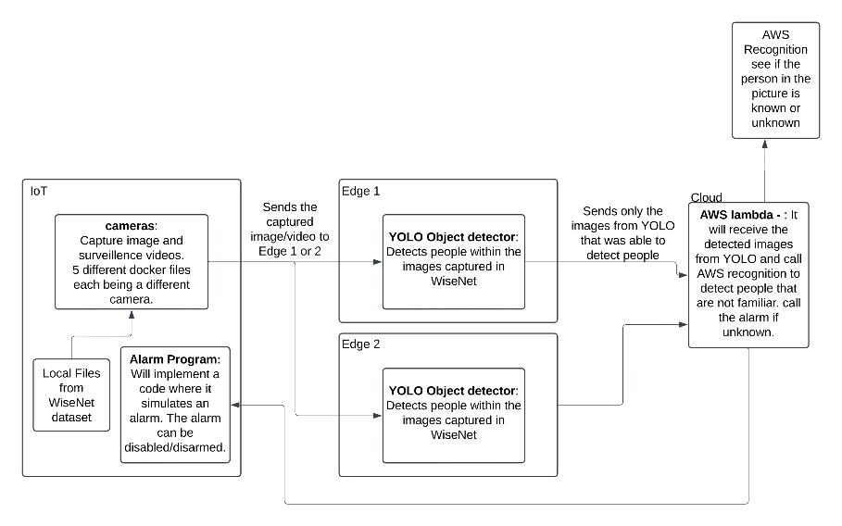

Part 3 implementation details:

**IOT devices –** Each camera is implemented in our local machines as a python file running inside its own docker container. Each of the containers is emulating a camera using datasets from Wisenet and extracting a frame every 0.1 seconds. Thus the frames are being sent to the edge devices every 0.1 seconds.